| Software design |
| --- |
| Student mark manager |
| Version 1.0 |
| Prepared by class SE1440, Group 5  Do Tuan Thanh  Nguyen Duy Phúc  Tran Tien Dat  Tran Manh Dat |

**Contents**

Document description **4**

SRS overview **4**

2.1. List of system users 4

2.2. List of use cases 4

2.3. Use case diagram 6

2.3.1. Preliminary use case diagram 6

2.4. Activity diagrams of use case scenarios 7

2.4.1. Activity diagram for use case “Change password” 7

Data model **8**

Entity Relationship Diagram 8

Table details/Chi tiết các bảng 8

Table name: Mon 8

Table name: Giang vien 9

Table name: Lop 9

Table name: Khoa 9

Table name: Sinh vien 9

Table name: Ket qua (learn) 10

3.2.7. Table name: teach 11

Class diagram (p.61 – p70) **12**

List of classes in the Layers 12

Modeling the Class Behaviors - sequence diagrams 12

Sequence diagram for use case “Borrow copy” 12

Sequence diagram for use case “Return copy” 13

Sequence diagram for use case “Reserve Book” 14

User Interface Model Design (p. 70 – p.74) **15**

User interface model design 15

51.1. Screen “Doi mat khau” 15

51.2. Screen “Dang nhap” 15

51.3. Screen “Quan ly nguoi dung” 16

51.4. Screen “Mon hoc” 16

51.5. Screen “khoa” 17

51.6. Screen “lop” 17

51.7. Screen “sinh vien” 18

51.8. Screen “giangvien” 18

51.9. Screen “deim mon hoc” 19

51.10. Screen “tìm kiem” 19

Interface Flow Diagrams (p. 51) 20

Revision history

| **Date** | **Authors** | **Modifications** | **Version** |
| --- | --- | --- | --- |
|  |  |  |  |
|  |  |  |  |
|  |  |  |  |
|  |  |  |  |
|  |  |  |  |

# Document description

This document describes solution version 1.0 for the Student mark manager. It is divided into the following sections:

* In section 1 an overview of the Student system’s requirements will be provided, including the list of system users, use cases, use case diagram, and activity diagrams that describe the most important use case scenarios.
* In section 2 an E-R diagram and all tables of the Library system in detail will be presented.
* In section 3 all classes organized in the layers and their behaviours for the most important use cases will be presented.
* In section 4 the most screen prototypes will be presented.

# SRS overview

## 2.1. List of system users

1. Manager: The person who manages the system

2. Student: The person search for information marks.

3. Teacher: The person manages marks information of student and search marks.

## 2.2. List of use cases

1. Manage mark

2. Change password

3. Log out

4. Log in

5. Search

6. Manage account

7. Manage teacher

8. Manage major

9. Manage student

10. Manage class

11. Manage subject

12.Add

13.edit

14.delete

## 2.3. Use case diagram

### 2.3.1. Preliminary use case diagram

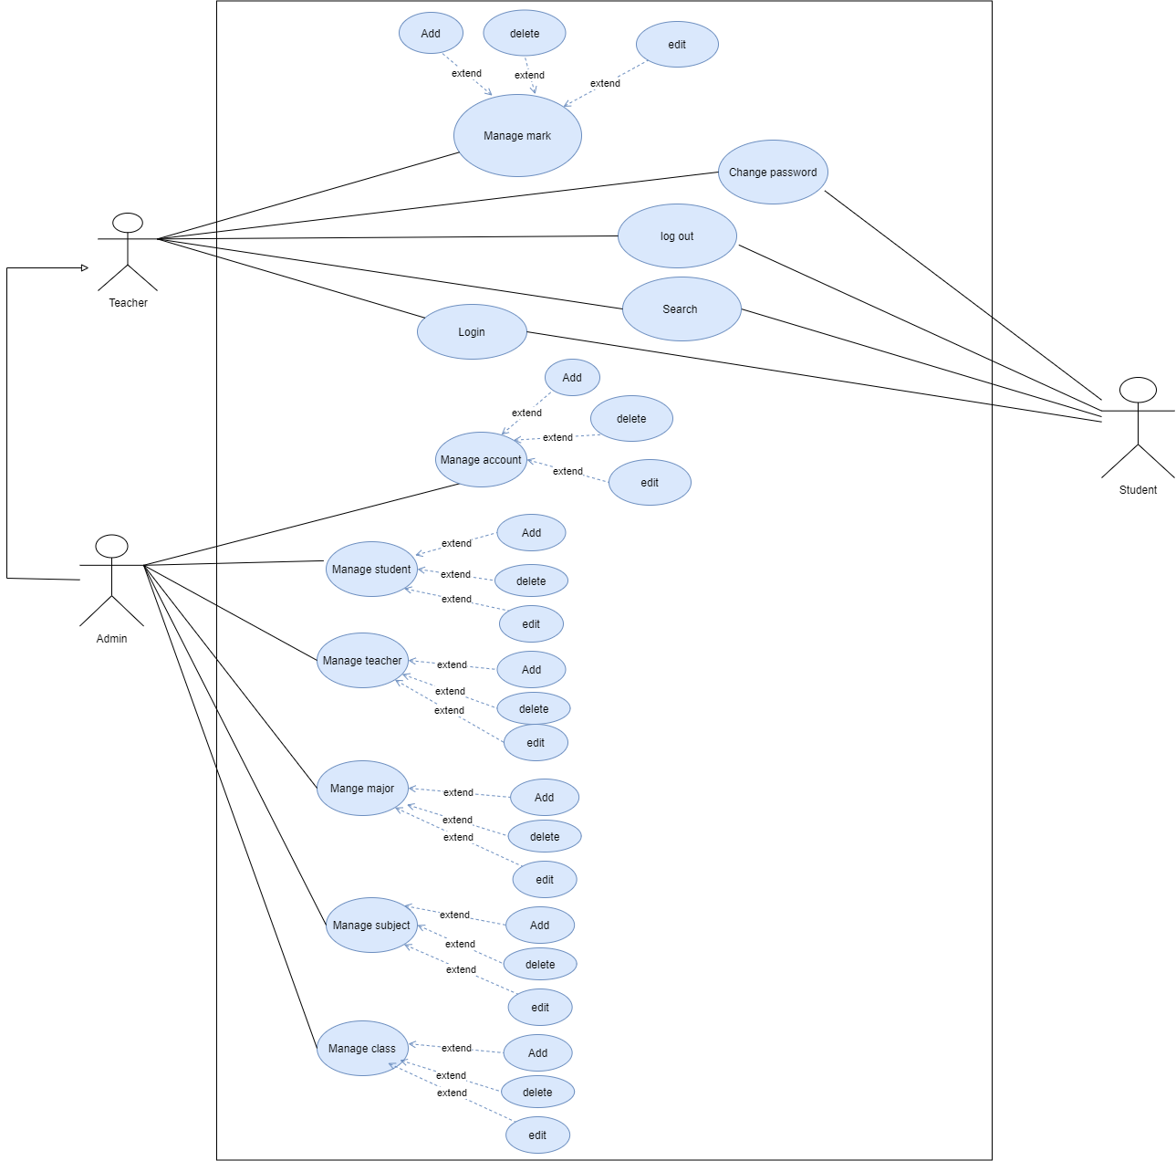

## 2.4. Activity diagrams of use case scenarios

### 2.4.1. Activity diagram for use case “Change password”

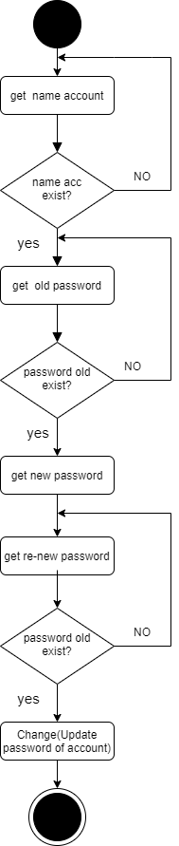

### 2.4.2. Activity diagram for use case “Search marks of students”

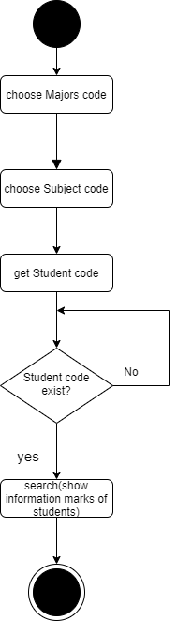

# Data model

## Entity Relationship Diagram

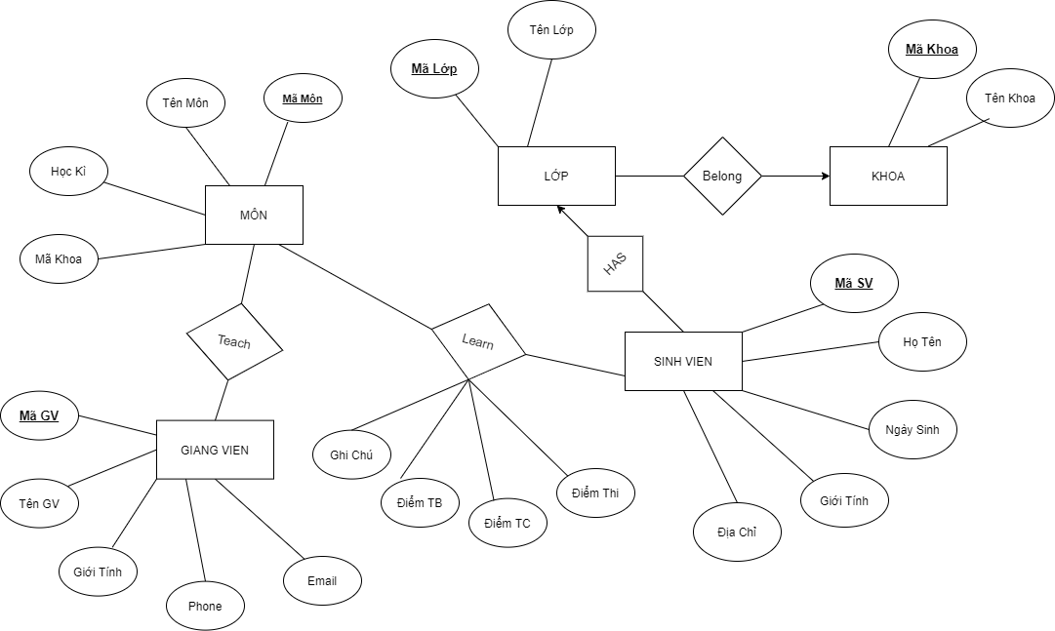

## Table details/Chi tiết các bảng

Note: Attribute with underline is Primary key

### Table name: Mon

| **Field name** | **Type** | **Size** | **Note** |
| --- | --- | --- | --- |
| MaMon | nvarchar | 10 | Primary key |
| HocKy | nvarchar | 10 | Allow nulls |
| MaKhoa | nvarchar | 10 | Foreign key |
| TenMon | nvarchar | 50 | Not nulls |

### Table name: Giang vien

| **Field name** | **Type** | **Size** | **Note** |
| --- | --- | --- | --- |
| MaGV | nvarchar | 10 | Primary key |
| Ten | nvarchar | 30 | Allow nulls |
| GioiTinh | nvarchar | 10 | Allow nulls |
| Phone | nvarchar | 15 | Allow nulls |
| Email | nvarchar | 20 | Allow nulls |

### Table name: Lop

| **Field name** | **Type** | **Size** | **Note** |
| --- | --- | --- | --- |
| TenLop | nvarchar | 50 | Allow nulls |
| MaLop | nvarchar | 10 | Primary key |
| MaKhoa | nvarchar | 10 | Foreign key |

### Table name: Khoa

| **Field name** | **Type** | **Size** | **Note** |
| --- | --- | --- | --- |
| Ten khoa | nvarchar | 50 | Allow nulls |
| Ma khoa | nvarchar | 10 | Primary key |

### Table name: Sinh vien

| **Field name** | **Type** | **Size** | **Note** |
| --- | --- | --- | --- |
| Ma sv | nvarchar | 10 | Primary key |
| Ho ten | nvarchar | 50 | Allow nulls |
| Ngày sinh | nvarchar | 10 | Allow nulls |
| Gioi tinh | nvarchar | 5 | Allow nulls |
| Dia chi | nvarchar | 50 | Allow nulls |
| MaLop | nvarchar | 10 | Allow nulls, Foreign key |

### Table name: learn

| **Field name** | **Type** | **Size** | **Note** |
| --- | --- | --- | --- |
| Diem thi | nvarchar | 10 | Allow nulls |
| Diem TC | nvarchar | 10 | Allow nulls |
| Diem tb | nvarchar | 10 | Allow nulls |
| Ma SV | nvarchar | 10 | Foreign key |
| Ma mon | nvarchar | 10 | Foreign key |
| (MaSV,MaMon) |  |  | Primary Key |
| Ghi chu | nvarchar | 100 | Allow nulls |

## 3.2.7. Table name: teach

| **Field name** | **Type** | **Size** | **Note** |
| --- | --- | --- | --- |
| Ma mon | nvarchar | 10 | Foreign key |
| Ma GV | nvarchar | 10 | Foreign key |
| (MaMon,MaGV) |  |  | Primary Key |

# Class diagram (p.61 – p70)

## List of classes in the Layers

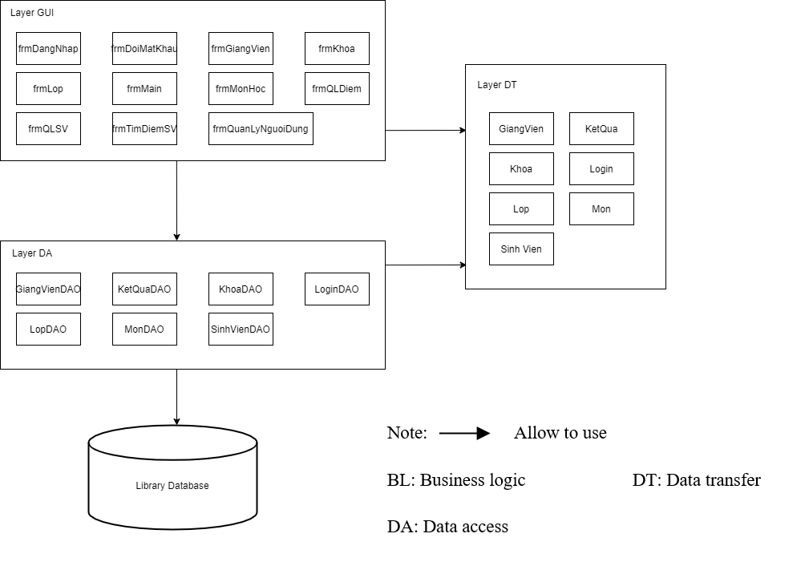

# User Interface Model Design (p. 70 – p.74)

## User interface model design

### 51.1. Screen “Doi mat khau”

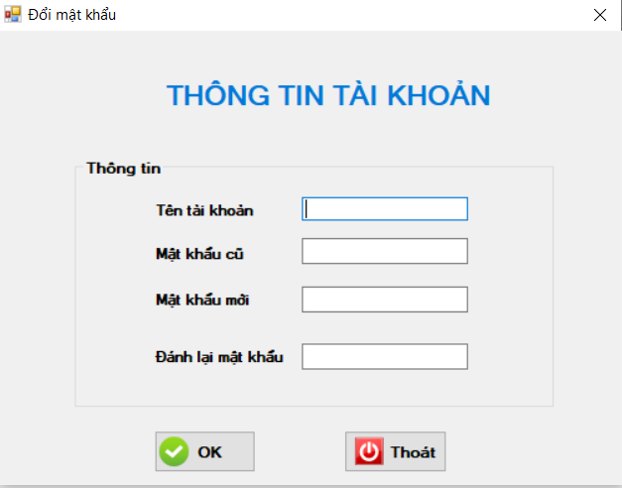

### 51.2. Screen “Dang nhap”

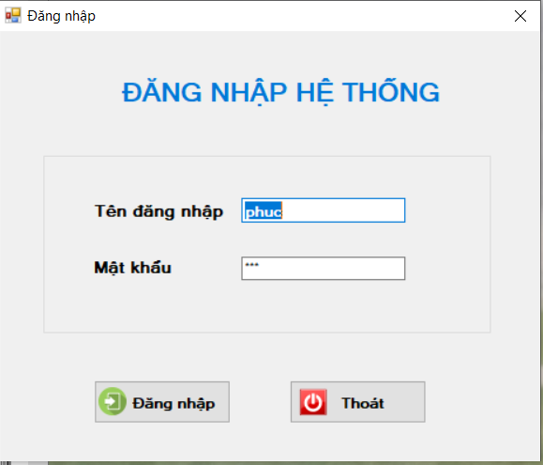

### 51.3. Screen “Quan ly nguoi dung”

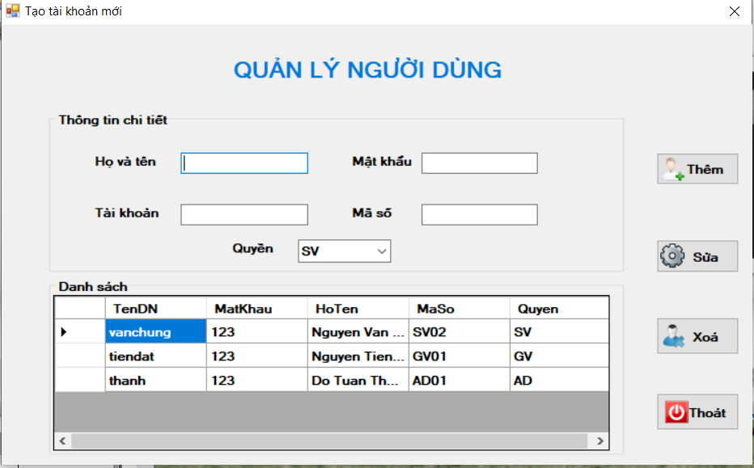

### 51.4. Screen “Mon hoc”

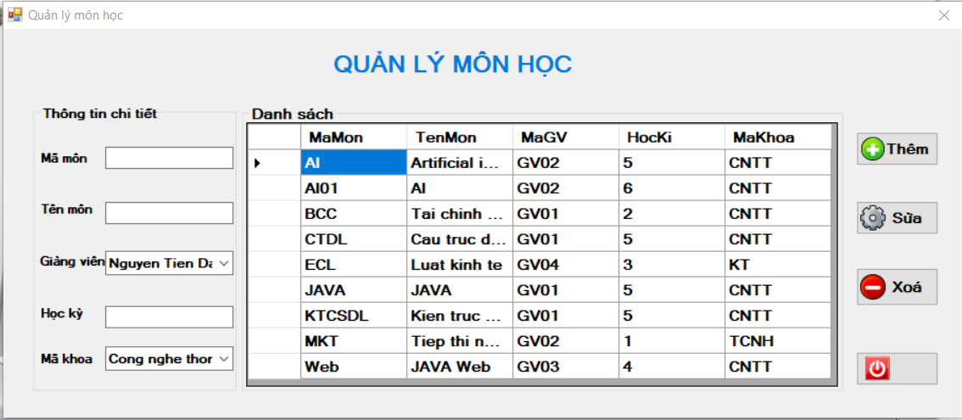

### 51.5. Screen “khoa”

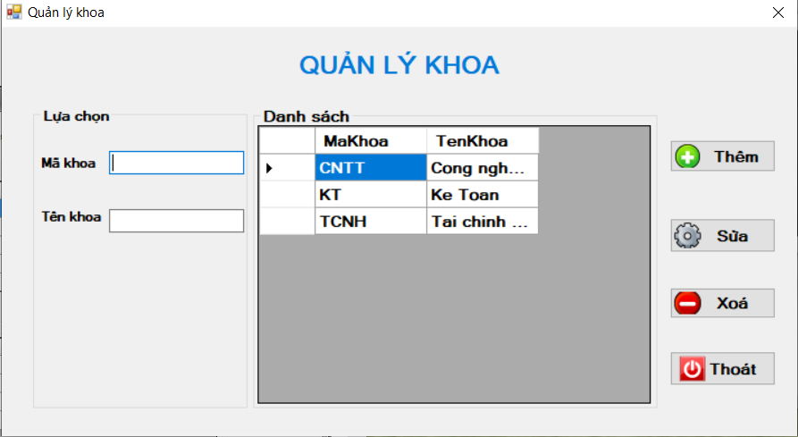

### 51.6. Screen “lop”

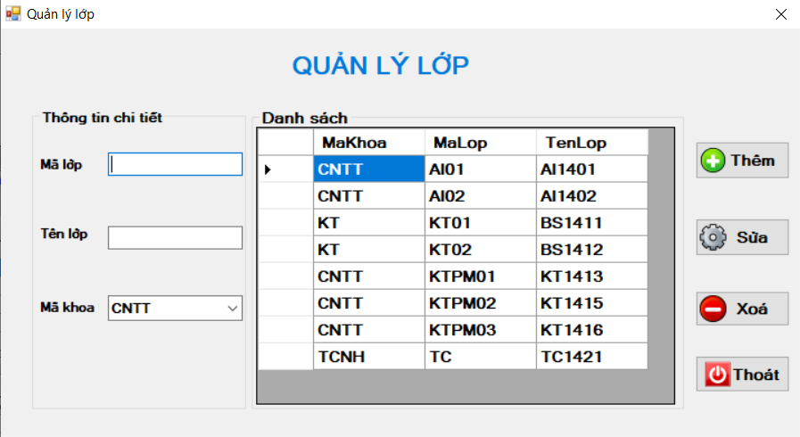

### 51.7. Screen “sinh vien”

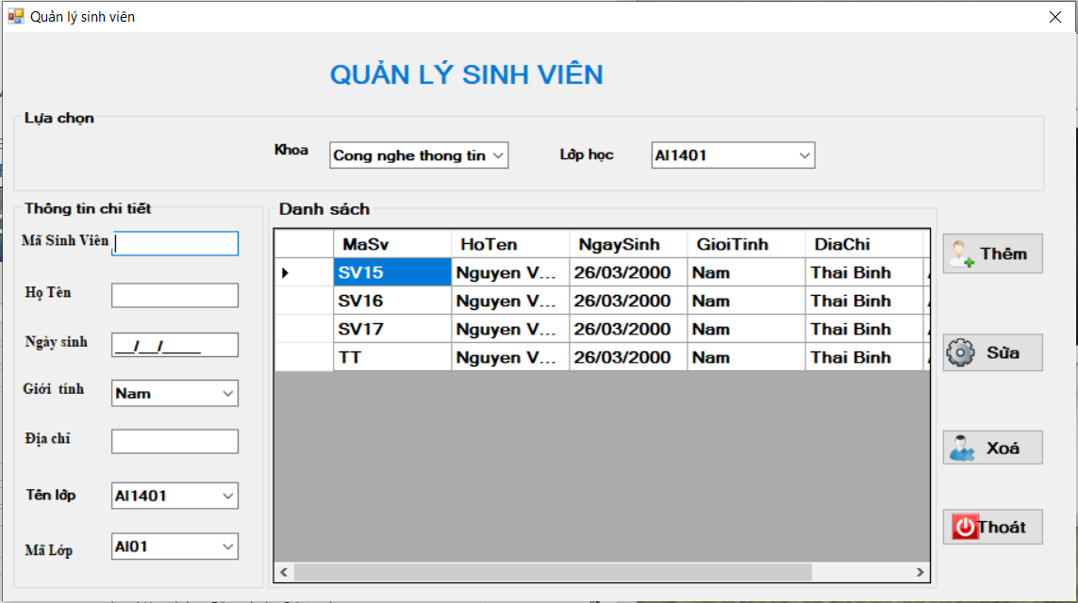

### 51.8. Screen “giangvien”

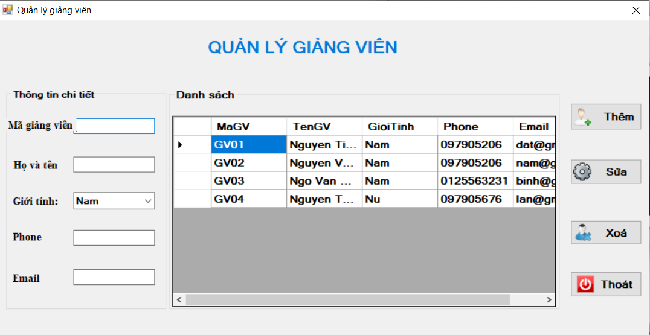

### 51.9. Screen “deim mon hoc”

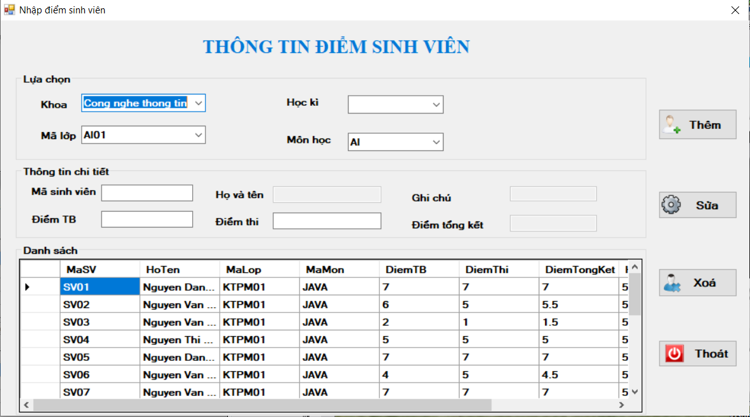

### 51.10. Screen “tìm kiem”

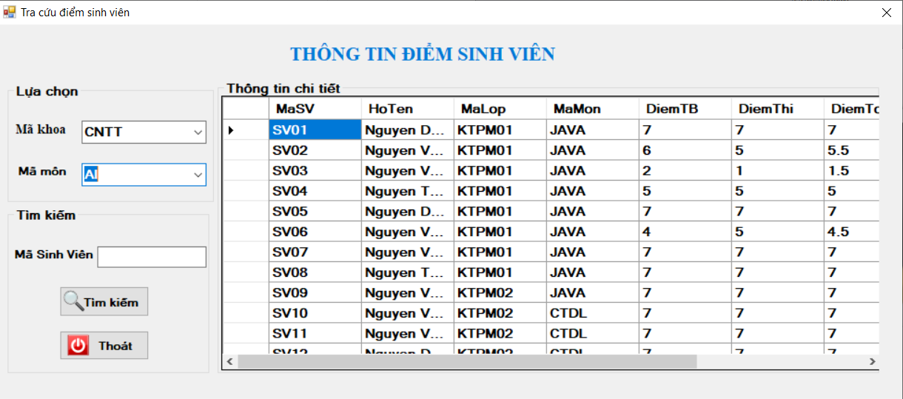

51.11. Screen “main”

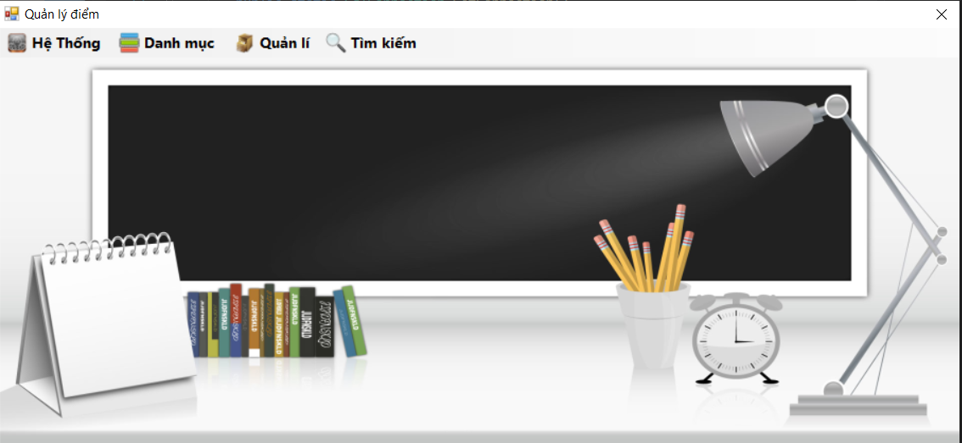

## Interface Flow Diagrams (p. 51)

